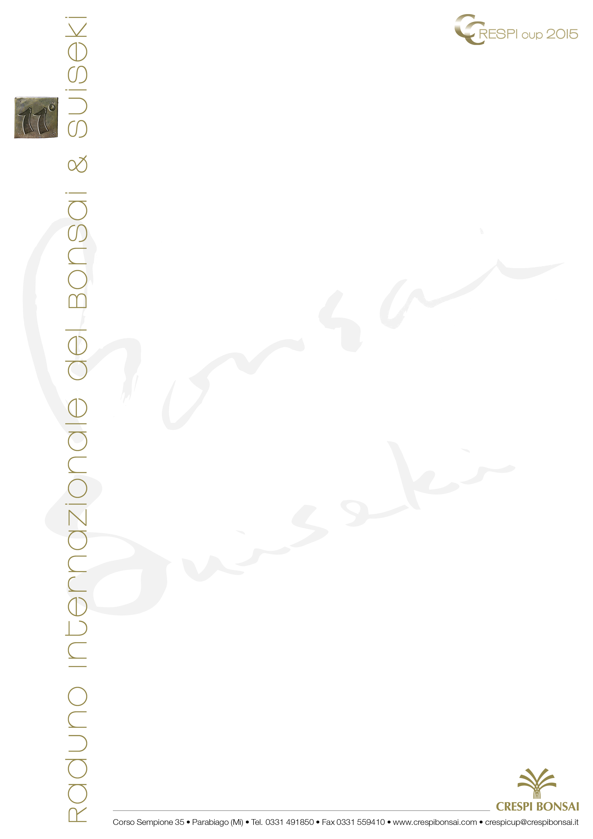
Dear participant,

with this form you can register in one or more competitions. It is possible to participate in more than one competition, but it is not possible to submit more than a bonsai, pot or suiseki for each competition. The registration demands will be examined according to the regulations of every competition and, in case of accepted demand, you will receive proper communication and information. To complete the registration procedure, it’s necessary to send a photo of the work (plant, pot or suiseki) you wish to present within 30th June 2015 to the following address:

 for poste:
11° Raduno Internazionale del Bonsai & Suiseki
Segreteria Crespi Cup 2015
Corso Sempione, 35 • 20015 PARABIAGO (Mi) • Italy

 for mail:
crespicup@crespibonsai.it

Registration

Name …………………………………………………………………… Surname ………………………………………………………………………………………………

Address …………………………………………………………………… City ……………………………………………………… Zip Code ……………………………

State Prov. ………………………………………………… Country …………………………………………………………………..………………………………………

Telephone………………………………………… Mobile phone……………………………………… E-mail …………………………………………………………

 Sect. 1 - Enthusiasts’ Exhibition • 11th-13th September - Bonsai data

Botanical name: …………………………………………………………………………………………………………………………………………………………………….
Height (cm): …………………………………………………………….
Length (cm): …………………………………………………………….
Ø of the trunk (cm): …………………………………………………
Sect. 2 - Suiseki Cup • 11th-20th September - Suiseki data
Classification: ………………………………………………………………………………………………………………………………………………………………………..
Height (cm): …………………………………………………….………
Lenght (cm): ……………………………………………………………
Width (cm): ……………………………………………………………..
Sect. 3 - Pot Cup • 18th-20th September - Pot data

Material: …………………………………………………………………………………………………………………………………………………………………………………
Height including tree (cm): ………………………………………
Lenght (cm): …………………………………..……………………….
Width (cm): ………………….…………………………………………..

With the form transmission, I authorize the treatment of my personal data according to the Italian Law (DLgs n. 196/2003).

Date ……………………………………………… Signature……………………………………………………………

